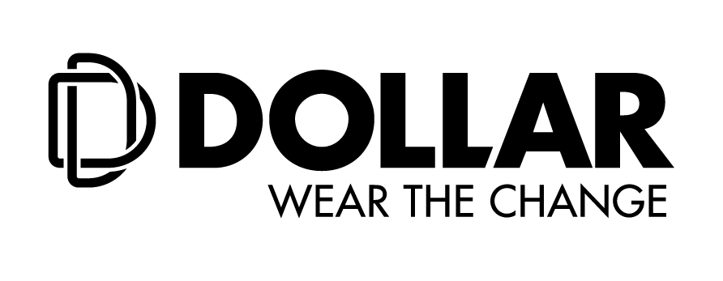

**Dollar Industries Ltd. unveils its brand new identity with Superstar Akshay Kumar**

***Hosts its first ever digital launch to revel its revamped vision - ‘Wear the Change’ - #DollarBadalGaya***

**28th May, 2020:** Dollar Industries Limited, one of India’s leading brands in the hosiery segment, unveiled its new corporate brand identity with a fresh vision of ‘Wear the Change’. Following the Government’s norms of social distancing, the company digitally revealed its newly designed logo along with superstar Akshay Kumar and Mr. Vinod Kumar Gupta, Managing Director, Dollar Industries, Ltd. The unique concept was one of its kind initiative by the brand to reach out to its consumers and share its message of ‘Wear the Change’ by staying in tune with digitization and changing times.

Hosted via e-press conference, Dollar Industries Ltd.’s re-branding exercise is the result of a calculated decision to create a youth friendly image along with an improved brand architecture and user friendly interface. The reinvigorated brand identity will assist in creating a synchronised brand portfolio and create a brand recall value amongst its end consumers and stakeholders. Dollar Industries Ltd. identifies the changing market trends and the need to innovate and keep up with the change. Therefore, the re-branding would ensure the brand responds to the market need for youthfulness and vigour.

***Logo Specifications:***

* The ‘Knitted and overlapping D’ symbolises Dollar’s identity and the knitting industry
* The new logo provides a distinct identity to the brand
* The present logo is simpler than the last one. It will be more easier to use the logo for any kind of communication purpose

Commenting on the occasion Mr. Akshay Kumar, Brand Ambassador, Dollar Industries Ltd. said, “My association with Dollar has been stupendous since the last ten years and today I am thrilled to be unveiling their new brand logo & identity through this virtual activity. Currently the pandemic across the world has generated an unprecedented circumstance and calls for widespread cooperation at all levels of society. In every situation, I search for positivity and as the Brand Ambassador of Dollar I urge everyone to stay safe during such difficult times, with a hope that we will be back soon."

Sharing his thoughts about the new brand revelation, Mr. Vinod Kumar Gupta, Managing Director, Dollar Industries Ltd. stated, “Our brand identity focuses on ‘Wear The Change’ which is aligned with our business ethics to constantly innovate and keep up with the trends and changing consumer needs. The reinvigorated brand identity will provide a new dynamism to the business profile internally, to the end customers and stakeholders.”

Mr. Gupta further added, “Our logo retooling exercise provides the brand a distinct identity. The ‘Knitted D’ symbolises our product line. The rebranding step has been taken to re-organize the brand architecture altogether making the brand visibility more precise and clearer. The company has become simpler in maintaining various categories which in return will make a positive change in the market.”

***User Friendly Presence:***

* Newly developed website with e-commerce platform
* Social Media presence for customers & stakeholders for update on product category and company activities

Designed for comfort and luxury, Dollar’s new logo evokes a feeling of inspiration and novelty, signifying warmth, comfort and positivity. The company has become simpler in maintaining various categories which are youth-friendly and aspire to make a positive change in the market. The brand has evolved over 40 years, and the rebranding exercise is a reflection of the company’s future vision and to showcases its strong foothold in the competitive market. The brand will include a wide array of products for men, women and kids such as briefs, vests, athleisure, leggings, thermals and many more.

**About Dollar Industries Limited:**

From a humble beginning as a hosiery brand to a leading name in the innerwear segment, Dollar Industries Limited ranks among the top hosiery and garment manufacturing giants in India, covering entire range of knitted garments, from basic wear to outer wear. Behind its success, lays a saga of business transformations, dedication, courage and confidence to swim against the tide and go beyond the call of duty. The focus has always remained on the demanding needs of a globalized world and end customer satisfaction. Today through its advanced quality products, Dollar has focused on achieving global excellence in cost, quality and productivity. The styles introduced by Dollar have always stayed in tune with the latest fashion.

Identical with top quality and value for money products, brand Dollar enjoys the trust of millions satisfied consumers across globe leaving far reaching footprints in global market. The company has a substantial pan-India presence and has established its market abroad, in countries like UAE, Oman, Jordan, Qatar, Kuwait, Bahrain, Yemen, Iraq, Nepal, and Sudan in past few years. The Company has also got listed in NSE & BSE in recent past.

Dollar Industries holds 15% of the total market share in the organised segment and is the first Indian innerwear company to have a fully integrated manufacturing unit which is equipped with all the latest processing technology and the top-most finishing range to produce finished raw material dyed in any possible colour. Dollar has focused on excellence in cost, quality and productivity.

Please visit website: (www.[dollarglobal.in/](https://www.dollarglobal.in/).in; BSE: Scrip Code 541403; NSE Scrip Code: DOLLAR)