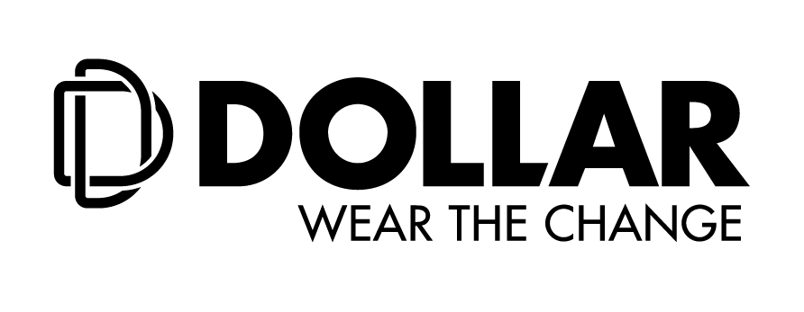

**Dollar Industries Limited Joins Hand With HealthGuard To Introduce**

**Anti - Viral Products**

**- Hosts An Insightful Webinar On #DontBringTheVirusHome Involving Eminent Doctors Of The Country For The Occasion -**

**Kolkata, 8thSeptember, 2020: Dollar Industries Limited** one of India’s leading brands in the hosiery segment has joined hands with Australia based company, **HealthGuard** and curated a new range of anti-viral products. The initial range consists of anti-viral masks and innerwear for men. The safe cosmetic based chemistry of HG AMIC is 100% and skin-friendly and remains active on treated fabric achieving excellent wash performance.

“We all want to protect ourselves and our loved ones as the pandemic is considered to be the most crucial global health calamity of the century. Keeping in mind our social responsibilities, Dollar Industries Limited has joined hands with HealthGuard, an Australia-based company that is a pioneer in innovative disease prevention technology for over 25 Years and curated a new range of anti-viral products. Made from cotton and non-woven fabrics, the product range features the perfect blend of science and comfort’’, said **Mr. Vinod Kumar Gupta, Managing Director, Dollar Industries Limited**.

To mark the occasion, Dollar Industries organised an insightful and knowledge driven panel discussion, **#DontBringTheVirusHome**, on an e-platform today. Amidst the continuous battle against the Covid-19 pandemic, the brand addressed the best measures to protect oneself along with their loved one. With a primary focus on **#DontBringTheVirusHome,**the panel discussion consisted of eminent medical practitioners - **Dr. Kunal Sarkar, Senior Vice-Chairman, Director and Head of Cardiac Surgery at Medica Superspeciality Hospital, Dr. Uttiya Deb, Clinical Pharmacologist, Burdwan Medical College, Dr. Shreevidya Venkatraman, Senior Consultant, Internal Medicine, MGM Healthcare, and Mr. Arindam Choudhuri, Business Head - Global, HealthGuard**along with**Mr Vinod Kumar Gupta, Managing Director, Dollar Industries Limited.**

As the lockdown restrictions are being lifted across various parts of the country, people are now adopting the ‘New Normal’ ways of sustenance. Today’s session was all about sharing the correct information and building awareness about **#DontBringTheVirusHome.** The panellist shared their insights and suggestions to create an awareness among the general public about personal hygiene and how to protect themselves now onwards with the new normal concept.

During his segment, **Dr. Kunal Sarkar** shared great information about the much-needed vaccination and the timeline for the same. He highlighted the ongoing R&D procedures across the globe to develop the vaccine. He also explained the importance of social distancing, maintaining regular hygiene and sanitization methodology.

**Dr.Shreevidya Venkatraman** shared some of her valuable insights on various important precautionary measurement during unlock phases. She mentioned that though masks are becoming a part of our regular attire, where people are experimenting with designs and patterns but the right kind of mask that can be most effective during this time. She shared information about the apt choices that one should make about masks.

**Dr. Uttiya Deb,** shared his opinion on the ongoing unlock phase and the required need to strike a socio-economic balance, while stepping out of their houses and resuming to regular day to day activities. He pointed out that the people are sceptical and in constant panic mode about the best preventive measures that can keep them and their families safe. Though the immunity boosters have become extremely popular, he felt that the right kind of safety measures is equally important.

Joining the panel discussion,**Mr. Arindam Choudhuri, Business Head - Global, HealthGuard** helped the audience to understand the concept of anti-viral fibre created across various segments in the industry. With an elaborate presentation, Mr. Choudhuri shared some unique information about HealthGuard products:

* *HealthGuard® products, being globally successful since 1991, with a proven track record commercializing intelligent biotech solutions*
* *HealthGuard® is the world leader in innovative disease prevention*
* *Scientific procedures of treating fabrics and making it effective against corona virus*
* *Proper Health and safety certifications*

“The lifting of lockdown may expose us to more threats than before, as glitches in social distancing may occur despite the best control measures. So, these new anti – viral masks are an effective way to keep the virus at bay. We are with the consumers and the community in these troubled times. It’s time that we take the new normal in our stride! With our new range of products hitting the markets across offline and e-commerce platforms, I continue to look at Dollar Industries Limited as a brand that is innovative, responsible and optimistic”, added **Mr. Vinod Kumar Gupta**.

Dollar Anti - Viral masks are priced at Rs.120 for a pack of 2pcs and the Men’s innerwear comprising of vests, briefs and trunks are priced between Rs.130 to Rs.190 and are available across the country.

***Note: Dollar Anti-Viral Range***

* *99.94% effective under against corona or similar viruses.*
* *24x7 silent protection against deadly germs*
* *Double layered super breathable fabric.*
* *Reusable eco-friendly design*
* *The mask fabric is chemically treated by a chemical by HealthGuard. Australia*
* *Available over e-commerce platforms and offline stores*

**About Dollar Industries Limited:**

From a humble beginning as a hosiery brand to a leading name in the innerwear segment, Dollar Industries Limited ranks among the top hosiery and garment manufacturing giants in India, covering entire range of knitted garments, from basic wear to outer wear. Behind its success, lays a saga of business transformations, dedication, courage and confidence to swim against the tide and go beyond the call of duty. The focus has always remained on the demanding needs of a globalized world and end customer satisfaction. Today through its advanced quality products, Dollar has focused on achieving global excellence in cost, quality and productivity. The styles introduced by Dollar have always stayed in tune with the latest fashion.

Identical with top quality and value for money products, brand Dollar enjoys the trust of millions satisfied consumers across globe leaving far reaching footprints in global market. The company has a substantial pan-India presence and has established its market abroad, in countries like UAE, Oman, Jordan, Qatar, Kuwait, Bahrain, Yemen, Iraq, Nepal, and Sudan in past few years. The Company has also got listed in NSE & BSE in recent past.

Dollar Industries holds 15% of the total market share in the organised segment and is the first Indian innerwear company to have a fully integrated manufacturing unit which is equipped with all the latest processing technology and the top-most finishing range to produce finished raw material dyed in any possible colour. Dollar has focused on excellence in cost, quality and productivity.

Please visit website: (www.[dollarglobal.in/](https://www.dollarglobal.in/).in; BSE: Scrip Code 541403; NSE Scrip Code: DOLLAR)