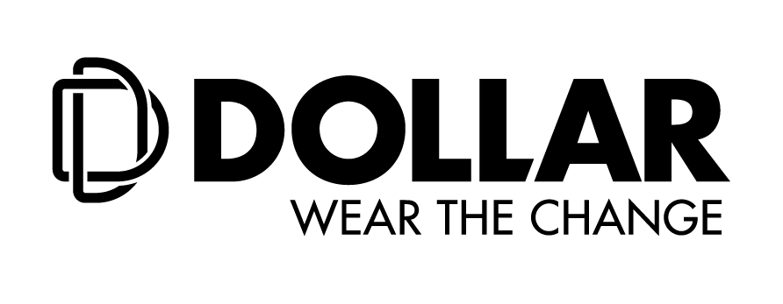

**Dollar Industries Limited inaugurates 4 MW solar power plant in Tirupur**

**Tirupur/Kolkata, 1stOctober, 2020:** Dollar Industries Limited, one of the leading apparel brands in India, commissioned a 4 MW solar power plant at their manufacturing facility in Tirupur. The solar plant is a part of Dollar’s ‘Green Mission’ initiative and has a capacity of generating 75 lakhs power units annually.

Dollar’s objective for installing the solar plant is to not only reduce costs but also make the spinning unit at Tirupur sustainable and self-reliant. To produce 1kg of cotton yarn, the cost of power is approximately Rs. 27-28 which is expected to feed almost 50% of the daily consumption at the spinning unit. Moreover, the solar plant will help in curbing the CO2 emissions by 9000kgs/per day with a sustainable environment.

Sharing his thoughts about the initiative, **Mr. Vinod Kumar Gupta, Managing Director, Dollar Industries Limited** stated, “We have always been a responsible corporate with a substantial focus on environment friendly practices. With the current pandemic situation, it is imperative to reduce costs and at the same time also create a clean and eco-friendly manufacturing facility protecting the environment. We at Dollar have been making constant efforts to operate in an environmentally friendly and sustainable manner.”

“By keeping a close watch on the development process, we mainly maximize the utilization of water, energy and our natural resources, safeguarding the earth by reducing our carbon footprints. This project is in line with Dollar’s commitment to develop renewable production capabilities to develop quality products for our consumers”, added Mr. Vinod Kumar Gupta.

During the inauguration, **Mr. Binay Kumar Gupta, Executive - Managing Director – Promoter** stated, “The solar plant has been commissioned by Indway Power Energy Pvt. Ltd., who is the EPC (Engineering, Procurement and Construction) partner from Coimbatore. The power generated from the solar plant will primarily used for our spinning unit. In case of excess power will be utilized to feed the dyeing unit, which is located at SIPCOT Industrial Park, Perundurai.

**Mr. Bajrang Kumar Gupta, Executive - Whole Time Director – Promoter, Dollar Industries Limited said,** “In the past, the company has invested in superior quality manufacturing assets and have utilized state-of-the-art technologies for developing environmentally sustainable work atmosphere. From installing a windmill for the energy needs of the manufacturing facility, utilizing Zero Discharge Water Treatment, to recycle and reuse the water waste from the facility, Dollar Industries Limited has always integrated the environmental friendly initiative in its business practices. These help us to not only reduce costs but also conserve the natural resources.”

Dollar Industries Limited has invested INR 18 crores for the plant and the payback period is expected to be 5 years.

**About Dollar Industries Limited**

**(**<https://www.dollarglobal.in/>**; BSE: Scrip Code 541403; NSE Scrip Code: DOLLAR)**

From a humble beginning as a hosiery brand to a leading name in the innerwear segment, Dollar Industries Limited ranks among the top hosiery and garment manufacturing giants in India, covering entire range of knitted garments, from basic wear to outer wear. Behind its success lay a saga of business transformation, dedication, courage and confidence to swim against the tide and go beyond the call of duty. The focus has always remained on the demanding needs of a globalized world and end customer satisfaction. Today through its advanced quality products, Dollar has focused on achieving global excellence in cost, qualityand productivity. The styles introduced by Dollar have always stayed in tune with the latest fashion.

Identical with top quality and value for money products, brand Dollar enjoys the trust of millions satisfied consumers across globe leaving far reaching footprints in global market. The company has a substantial pan-India presence and has established its market abroad, in countries like UAE, Oman, Jordan, Qatar, Kuwait, Bahrain, Yemen, Iraq, Nepal, and Sudan in past few years. The Company has also been listed in NSE & BSE few years ago.

Dollar Industries Limited holds 15% of the total market share in the organized segment and is the first Indian innerwear company to have a fully integrated manufacturing unit which is equipped with all the latest processing technology and the top-most finishing range to produce finished raw material dyed in any possible color.

**For further information please contact:**

Sreeraj Mitra / Priyadarshini Bhan / Sayanjita Dey

Sagittarius Communications

Ph: 9007307884 / 8697719337 / 8697719315