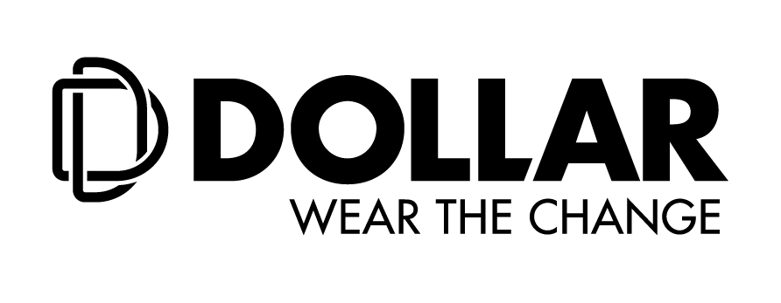

**Dollar Industries Limited donates Anti-Viral Face Masks to Paramilitary Forces in New Delhi**

*An initiative by Dollar Foundation, keeping in mind the health and safety of frontline heroes*

**New Delhi, September 17, 2020**: Dollar Industries Limited, a prominent name in the hosiery and knitwear segment recently launched its new range of anti-viral products, in association with HealthGuard, Australia. As a part of Dollar’s corporate social responsibility, Dollar Foundation donated 2000 pieces of anti-viral masks to the frontline heroes at CRPF and CISF in New Delhi.

**Mr. Pramod Gupta, Director, Dollar Industries Limited** met **Mr. Rajesh Ranjan, Director General, CISF** and handed over 1,000 Anti-Viral face masks to him. Additionally, **Mr. Amit Kumar Singh, Regional Head Marketing (North India) at Dollar Industries Limited** met **Inspector General of CRPF, Mr. Ajay Kumar Yadav** and donated 1,000 Anti-Viral face masks to him.

Sharing his thoughts about the activity, **Mr. Vinod Kumar Gupta, Managing Director, Dollar Industries Limited** stated, “The COVID-19 has taken the country by storm and in distressing times like these our warriors at CRPF and CISF have taken the initiative of collaboration within communities by maintaining vigilance in the form of law and order during the lockdown. As a virtuous Indian we salute the frontline COVID warriors for their paramount and indispensable services. As a small gesture of respect Dollar Industries Limited, shared their newly introduced anti-viral masks to the Central Industrial Reserve Force (CISF) and Central Reserve Police Force (CRPF) to support our fight against the virus.”

**Mr. Rajesh Ranjan, Director General CISF**and **Mr. Ajay Kumar Yadav, Inspector General of CRPF**were overwhelmed with the kind gesture and appreciated the organization’s effort in reaching out to the forces during the ongoing pandemic. While expressing their gratitude, they congratulated the organization for creating products that are developed keeping mind the health and safety in these unprecedented times.

With an elaborate vision focusing on **#DontBringTheVirusHome**, Dollar Industries Limited curated a range of products in association with HealthGuard, Australia. The products are 99.94% effective against corona virus and can be of great assistance to consumers as they adapt to the ‘New Normal’ ways of living.

**About Dollar Industries Limited:**

Dollar Industries Limited is amongst the top 3 hosiery and knitwear brands in the country and holds 15% market share in the segment. Dollar is the first Indian innerwear company to have a fully integrated state-of-the-art manufacturing units. These units are located in Tirupur, Kolkata, Ludhiana and Delhi. Equipped with all the latest production technology – the finished goods are dyed in any possible colour alongside excellent quality.

Identical with top quality and value for money products, brand Dollar enjoys the trust of millions satisfied consumers across globe leaving far reaching footprints in global market. The company has a substantial pan-India presence and has established its market abroad - in countries like UAE, Oman, Jordan, Qatar, Kuwait, Bahrain, Yemen, Iraq, Nepal, and Sudan in past few years. The Company has also got listed in NSE & BSE in recent past.

Founded in 1972-73 as Bhawani Textiles, the brand has revamped its brand and corporate portfolio over the years. Starting as a small hosiery brand to the most renowned name in the segment, success did not come easy. Constant innovation, dedication, confidence, evolution and focus are the key foundations of the company.