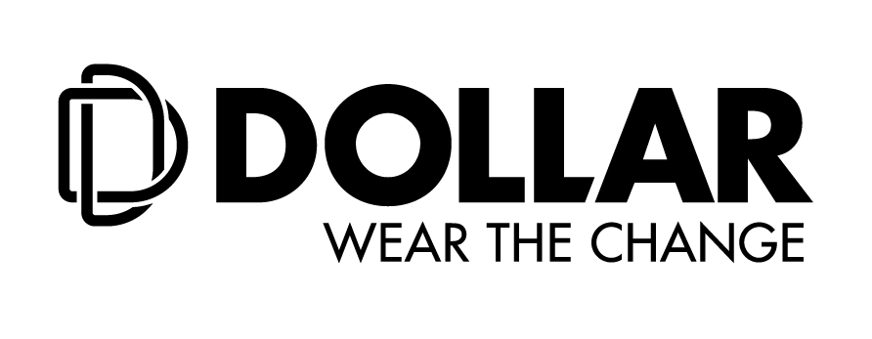

**Dollar Industries Limited**

|  |
| --- |
| **(CIN : L17299WB1993PLC058969)** |
| **Regd. Office:** Om Tower, 15th Floor, 32, J L Nehru Road, Kolkata - 700071, West Bengal, India |
| **Phone No.:** (033) 2288 4064-66, **Fax:** (033) 2288 4063 |
| **e-mail:** care@dollarglobal.in, **Website:** www.dollarglobal.in |

***Dollar Industries Limited hosts 27thAnnual General Meeting***

**Kolkata, 2nd September, 2020:** Dollar Industries Limited (**BSE: 541403; NSE : DOLLAR)**, one of the leading Garment & Hosiery Company in the country conducted its 27th Annual General Meeting on 1st September, 2020 through Video Conferencing due to the Covid-19 pandemic.

**Highlights of 27th Annual General Meeting**

* Declaration of dividend @ 85 % i.e. 1.70 per share (on FV Rs. 2 each) on equity shares for FY 2019-20.
* Adoption of Audited Financial Statements for the FY 2019-20 having consolidated revenue of Rs. 974.03 crores and PAT of 57.34 crores.

During the AGM, the shareholders approved all the resolutions including the adoption of Audited Financial Statements of the company for the FY 2019-20 and approval of final dividend of Rs. 1.70 per share. The cut-off date for final dividend payout was 25th August, 2020.

While addressing the shareholders, Mr. Vinod Kumar Gupta, Managing Director, Dollar Industries Limited said, “The Covid-19 pandemic, has changed and disrupted life for everyone in this country, it is a tough situation where the organization is trying to strike the right balance between employee safety and efficiency. While the outlook is challenging and uncertain, we are determined to play our part to recover from the crisis.”

On the way forward, he added, “As the global economy is battling the adverse effects of the pandemic, companies and businesses all around are making brave business decisions every day. Now is the time that the businesses need to think out of the box as well as be adaptive. It is the need of the hour for companies to re-examine the traditional and conventional procedures and implement new appraisal processes and programs to sustain and scale their business”.

In May 2020, Dollar Industries Limited concluded its first ever digital launch with our brand ambassador Mr. Akshay Kumar. In order to simplify and consolidate its product offering, Dollar Industries Limited revamped its brand architecture and introduced a fresh vision ‘Wear The Change’.

Additionally, keeping in mind the health and safety of its consumers, Dollar Industries Limited will soon launch a unique range of products. Clubbed with new age technology and Dollar’s trusted products, the upcoming range will be soon available for consumers across the country on e-commerce as well as offline stores.

**About Dollar Industries Limited (**<https://www.dollarglobal.in/>**; BSE: Scrip Code 541403; NSE Scrip Code: DOLLAR)**

From a humble beginning as a hosiery brand to a leading name in the innerwear segment, Dollar Industries Limited ranks among the top hosiery and garment manufacturing giants in India, covering entire range of knitted garments, from basic wear to outer wear. Behind its success lay a saga of business transformation, dedication, courage and confidence to swim against the tide and go beyond the call of duty. The focus has always remained on the demanding needs of a globalized world and end customer satisfaction. Today through its advanced quality products, Dollar has focused on achieving global excellence in cost, qualityand productivity. The styles introduced by Dollar have always stayed in tune with the latest fashion.

Identical with top quality and value for money products, brand Dollar enjoys the trust of millions satisfied consumers across globe leaving far reaching footprints in global market. The company has a substantial pan-India presence and has established its market abroad, in countries like UAE, Oman, Jordan, Qatar, Kuwait, Bahrain, Yemen, Iraq, Nepal, and Sudan in past few years. The Company has also been listed in NSE & BSE few years ago.

Dollar Industries Limited holds 15% of the total market share in the organized segment and is the first Indian innerwear company to have a fully integrated manufacturing unit which is equipped with all the latest processing technology and the top-most finishing range to produce finished raw material dyed in any possible color.

**For more information contact:**



|  |  |
| --- | --- |
| Mr. Shashankk Rakhecha  Manager – Finance & Accounts | Ms. Shashi Agarwal  Sr.VP– Corporate Strategy &Investor Relations |
| **Dollar Industries Limited** | **Dollar Industries Limited** |
| Tel: +91 9748262061 | M: +91 9830693972 |
| E-mail: shashankk.rakhecha@dollarglobal.in | E-mail: shashi.agarwal[@dollarglobal](mailto:care@dollarglobal).in |

**DISCLAIMER:**

*Certain statements that are made in the Press Release may be forward-looking statements. Such forward-looking statements are subject to certain risks and uncertainties like significant changes in economic environment in India and overseas, tax laws, inflation, litigation, etc. Actual results might differ substantially from those expressed or implied. Dollar Industries Limited will not be in any way responsible for any action taken based on such statements and discussions; and undertakes no obligation to publicly update these forward-looking statements to reflect subsequent events or circumstances.*