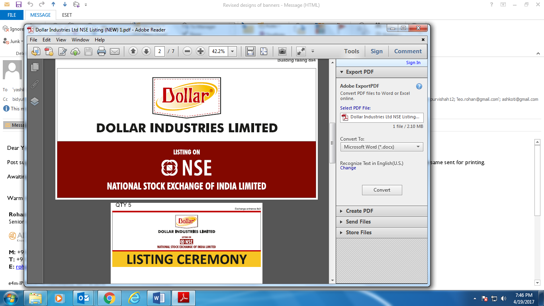

**Press Release For Immediate Publication**

**Dollar Industries Limited lists on NSE**

* ***Dollar intends to expand its product portfolio across range from kids to adults***
* ***Company to focus growth in exports***

**Mumbai, April 21, 2017:** Kolkata-headquartered Dollar Industries Limited, one of India’s leading hosiery companies, gets listed on National Stock Exchange (NSE) with effect from Friday, April 21, 2017. The listing of the Company on one of the premier stock exchanges of the country is expected to enhance the visibility for the Company’s equity shares and also provide liquidity for existing and prospective investors. Hem Securities Ltd. was the listing advisor to the Company.

**Mr Vinod Kumar Gupta, Managing Director, Dollar Industries Limited**, said, “Listing on one of the premier stock exchanges is a significant milestone for Dollar Industries and it is indeed a moment of pride for all of us at Dollar as we embark on a new journey with us being listed on the National Stock Exchange. Today we are the first Indian innerwear company with fully Integrated Manufacturing unit. The company has a market share of over 15% in the branded knitwear market. The company has its presence in the entire length and breadth of the country in over 800 towns and cities in India and products are sold by over 80,000 retailers pan India. We are one of the fastest growing innerwear companies in India, reporting annual revenue of Rs.830 crore for the period 2015-16 with exports contributing to Rs.69.3 crore for the financial year 2015-16.”

Further Mr Gupta added that, “The Company is one of the leading knitwear brands in India and has its presence in Nepal, Middle East and Gulf countries. Company has it reputation as highest selling knitwear brands in UAE and Middle East.

We would like to further grow our exports in the existing countries as well as we will be looking to venture in new geographies.” Dollar has also achieved the status of “Export House” in accordance with the provisions of foreign trade policy of Ministry of Commerce and Industry, Government of India.

The Company over the years has grown as the first totally integrated hosiery manufacturing company in India with units in Kolkata, Tirupur, Delhi and Ludhiana. One of the state-of-art New Processing Unit is located at (cont.)

SIPCOT, Perundurai - Erode, district in Tamil Nadu. The unit is well equipped with the Latest Processing Technology to produce finished raw material dyed in any possible colour. We have got a production capacity of about 13.5 tons a day having 6 HPHT (High Pressure High Temperature) machines installed. This factory has a capacity of 1000 KL Zero Liquid Discharge with multiple evaporators and we follow the Norms of PCB, comply with labour laws and various Quality Systems. We also own a Spinning Unit situated at Vedasandur, Dindigul district.

R&D plays a major role at Dollar Industries and is an ongoing process so that all the products combine fashion and functionality. State-of-art technologies have reinforced our facilities and will add new excellence to the products. The frontier of competitive advantage is the customer interface.

The company began its journey with the signature brand ‘*Dollar*’. Later, the brand Dollar Bigboss launched after Dollar brand, which achieved popularity among consumers. Bollywood celebrity actor Akshay Kumar is the Brand Ambassador of Dollar Bigboss and he has contributed significantly in the success of the brand over the last six years. The company also has introduced Kids wear range “Champion”, women’s wear under the brand name “Missy” and casual wear range called “Force”. Dollar Industries were the first Indian Innerwear manufacturing company to introduced Micro Modal fabrics in inners.

The overall range of products at Dollar Industries includes vests, briefs, trunks with latest cuts and fits. In apparel category, there is basic and fashion denims, t-shirts, gym-vests, bermuda and track pants. For winter, the company has premium thermals for men, women and children. While, the women’s range includes camisoles, panties and leggings.

The company is committed to develop, improve and maintain an efficient quality management system in compliance with ISO 9001:2015 International Standard.

**For further details contact:** Adfactors PR: Purvi Shah 09833431331/ 9820531932