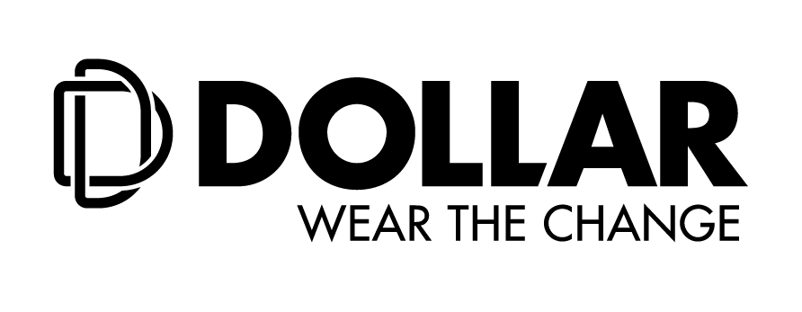

**Press Release**

**Dollar Industries Limited Launches New Ad Campaigns For**

**Dollar Bigboss and Dollar Missy**

**Kolkata, 12th October, 2020: Dollar Industries Limited,**a frontrunner in the hosiery industry, launches two new ad campaigns for Dollar BigBoss and Dollar Missy featuring Bollywood superstar, **Akshay Kumar** and renowned actress, **Chitrangada Singh** respectively.

Dollar has a long and strong association with their brand ambassador, Akshay Kumar. The company has shot nine TVC campaigns with the actor for Dollar Bigboss. This strong partnership has not only enhanced but also propagated the brand’s values and ethos. The tagline for Dollar Bigboss, ‘Fit Hai Boss’, has not only evolved with time but also brilliantly captures brand’s differentiation and has received a positive response from the customers. After the first TVC with Akshay Kumar in 2009, the company has witnessed 200% growth within a year and post that has witnessed 10-14% growth year-on-year.

In the latest Dollar Bigboss commercial, the plot of the film is pivoted on the concept of cloning. The film reveals, though Akshay’s perfect clone has been successfully designed, it fails one final and most vital test. Unlike the Dollar BigBoss vest worn by Akshay, his clone’s vest gets easily ripped off portraying only the original brand can stand up to the test of advanced strength and durability.

In a bid to attract today’s multi-tasking urban women, Dollar’s new campaign for Dollar Missy reflects the brand’s readiness to adapt to changing consumer trends and break existing stereotypes when it comes to fashion. The campaign film featuring Bollywood star Chitrangada Singh showcases how Dollar Missy enables today’s Gen Y woman to get ready in a jiffy so that she may seamlessly juggle between their personal, professional and social lives.

Both the campaigns are developed by **Lowe Lintas Kolkata** and has been directed by renowned ad-film maker, **ShivenSurendranath**.

“We have expanded the Bigboss portfolio to include not just innerwear but also athleisure, gymwear and casuals. With the considerable amount of success the brand has received has resulted in a spate of spurious duplicates in the market. Hence, we felt it is time to drive home the message that not every innerwear is a Dollar Bigboss and also wanted our long time payoff to depict something more modern and technology driven”, **Mr. Vinod Kumar Gupta, Managing Director, Dollar Industries Limited**.

At Dollar, we always believe in reinventing ourselves. Exactly the reason why we have gone beyond the repertoire of basic everyday necessities like camisoles and panties and expanded our product horizon to include fashionable leggings, loungewear and casuals to compliment the wardrobe of today’s woman. Armed with an enviable range of womenswear, we felt it was time for us to break old-standing beliefs as well”, added **Mr Gupta**.

Speaking on the idea behind the two campaigns, **Janmenjoy Mohanty, Regional Creative Officer, Lowe Lintas** said, “Fit Hai Boss as a tagline has always worked wonders for Dollar Bigboss and this time around we have used the phrase to develop a plot which is futuristic but at the same time it delivers a key message – Bigboss can’t be cloned. This imagery goes hand-in-hand with the newly created Dollar brand identity which speaks of the modern times, the science and innovation involved. Akshay is a brilliant actor who pulls off the film with flying colours. With regards to Missy, the concept was derived from the product itself. These easy-to-slip-on legwear are meant for a wide variety of occasions and uses and lends itself perfectly to the idea that today’s multi-tasking woman is game for #SpeedDressing.”

The campaign has been released on both electronic and online platforms.

**CREDITS: Bigboss**

**Agency:**Lowe Lintas Kolkata

**Planning**: Anurag Prasad &KritikaSawhney

**Creative**: JanmenjoyMohanty&Mohit Arora

**Account Management**: IndranilMitra, SiddharthGautam&Rohit Chakraborty

**Production**: Dharma 2.0 (**Director**: ShivenSurendranath)

**CREDITS: Missy**

**Agency:**Lowe Lintas Kolkata and LinConsult

**Planning:**Anurag Prasad &KritikaSawhney

**Creative:**JanmenjoyMohanty, Mohit Arora &Nisheeth Srivastava

**Account Management:**IndranilMitra, SiddharthGautam 7 Rohit Chakraborty

**Production:**Dharma 2.0**(Director:**ShivenSurendranath**)**

**About Dollar Industries Limited**

**(**<https://www.dollarglobal.in/>**; BSE: Scrip Code 541403; NSE Scrip Code: DOLLAR)**

From a humble beginning as a hosiery brand to a leading name in the innerwear segment, Dollar Industries Limited ranks among the top hosiery and garment manufacturing giants in India, covering entire range of knitted garments, from basic wear to outer wear. Behind its success lay a saga of business transformation, dedication, courage and confidence to swim against the tide and go beyond the call of duty. The focus has always remained on the demanding needs of a globalized world and end customer satisfaction. Today through its advanced quality products, Dollar has focused on achieving global excellence in cost, qualityand productivity. The styles introduced by Dollar have always stayed in tune with the latest fashion.

Identical with top quality and value for money products, brand Dollar enjoys the trust of millions satisfied consumers across globe leaving far reaching footprints in global market. The company has a substantial pan-India presence and has established its market abroad, in countries like UAE, Oman, Jordan, Qatar, Kuwait, Bahrain, Yemen, Iraq, Nepal, and Sudan in past few years. The Company has also been listed in NSE & BSE few years ago.

Dollar Industries Limited holds 15% of the total market share in the organized segment and is the first Indian innerwear company to have a fully integrated manufacturing unit which is equipped with all the latest processing technology and the top-most finishing range to produce finished raw material dyed in any possible color.

**For further information please contact:**

SreerajMitra / PriyadarshiniBhan / SayanjitaDey

Sagittarius Communications

Ph: 9007307884 / 8697719337 / 8697719315