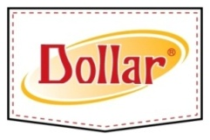
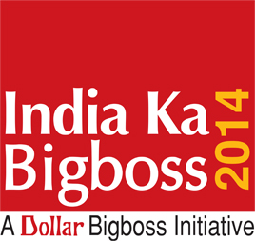
Press Release

India Ka Bigboss 2014 Tableau Starts Its Journey From Kolkata
- A unique initiative by Dollar Bigboss to inspire every Indian to vote responsibly -
Kolkata; 21st March, 2014: With the election fever aggravating and the parties finalizing the candidates, 79 crores of eligible voters to be addressed to, the upcoming General Election has set an unprecedented amount of excitement within the mass. Dollar Industries Ltd being a responsible Indian company recently launched a nationwide campaign India Ka Bigboss 2014 to encourage electorates before General Election 2014 about the importance of participatory democracy – hence Vote Responsibly.

Mr Vinod Gupta, Managing Director, Dollar Industries Ltd, eminent painter Mr Wasim Kapoor & actress Ms Pallavi Chatterjee today flagged off a unique tableau as a part of the campaign “India ka Bigboss 2014”. The campaign is a noble exercise before general Election where one can choose their favourite personality from various categories like Music, Business, Sports or Politics, and nominate India Ka Bigboss 2014.

The specially designed tableaus carrying online voting facilities would travel across the country covering major cities. The mobile car would also be equipped with facilities of Offline Voting. The prime idea of having the tableau is to generate interest about voting within the youth of the country to build a better India.

“Bigboss is someone who can influence your life in some way or the other, directly or indirectly, no matter who you are. BigBoss is a personality who can inspire millions of Indians to achieve greater heights in the fields of Sports, Films, Music, Politics and Business. BigBoss is a highly capable person who will take India forward in her march towards becoming a true Global Super Power. Hence we decided to introduce a pre poll voting exercise to choose our India Ka BigBoss. This is an online campaign where every citizen of the country can participate and vote”, said Mr Vinod Gupta, Managing Director, Dollar Industries Limited.

Participating in the India Ka BigBoss 2014 is simple. You need to log on to www.indiakabigboss.com or visit the Dollar Facebook page www.facebook.com/dollarinternational, create an account by registering your Email ID/FB Account and nominate your favourite candidates in all the categories. One can also participate by giving missed call at 09555213567. The personality who receives the maximum nominations in each category will be declared India Ka Bigboss 2014.

About Dollar Industries
Dollar Industries Ltd, is today amongst the top three hosiery brands in India. The company has four manufacturing units in Kolkata, Tirupur (TN), Delhi and Ludhiana. Dollar Industries enjoys a 15% market share in the branded hosiery segment in India. Dollar Industries have recently started business in African market with Nigeria to reserve more export revenue. The company’s existing export markets are in Middle East and South East Asian Countries.

For further information please contact:
Sreeraj Mitra / Debarjun Kar / Kaushik Chatterjee
Sagittarius Communications
Ph: 9007307884 / 9874559911 / 9830006528

